Similar Figures Worksheet Name: _______________________________ Hour: _____

Fill in the blank with the appropriate word, phrase, or symbol to make a true statement.

1. Similar figures have the same ______________________ but not necessarily the same _______________.

2. The symbol _____________ means "is similar to" and the symbol ____________ is the abbreviation for the word
angle.

3. A ____________________ drawing is an enlarged or reduced drawing that is similar to an actual object or
place.

4. In similar triangles, corresponding _______________ are congruent and corresponding _________________ are in
proportion.

5. To find a missing side length set up and solve a ____________________. Put the measurements of the smaller figure on top and the bigger figure on the bottom.

Learning Goal # 1: I can identify the corresponding parts of similar figures.
Example: The figures in each pair are similar (ΔABC ~ ΔXYZ).
X
∠A corresponds with ∠____. AB matches with ______.
30°
Y
C
B
A
∠B matches with ∠____. BA corresponds with ______.
Z
D
∠C corresponds with ∠____. BC matches with ______.

Practice Problems
- ΔSIT ~ ΔDOG
First, label ∠D, ∠O, & ∠G on the small triangle. Then, fill in the blanks below:
O
T
I
S
G
∠D corresponds with ∠____. DO matches with ______.
∠O matches with ∠____. IT corresponds with ______.
∠G corresponds with ∠____. ST matches with ______.
Suppose ∠S = 25°, what is the measure of ∠D? _________.

- ΔHOT ~ ΔPIG
∠H corresponds with ∠____. PI matches with ______.
H
T
O
P
I
G
∠O matches with ∠____. IG corresponds with ______.
∠T corresponds with ∠____. GP matches with ______.

Learning Goal # 2: I can find the missing measurements of two similar figures.
Example 1: The figures in each pair are similar Example 2: The figures in each pair are similar
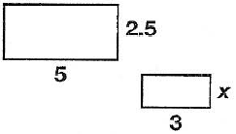
(ΔABC ~ ΔXYZ).

$$\frac{4}{8}=\frac{3}{?}$$
$$\frac{3}{5}=\frac{x}{2.5}$$
small Δ small

big Δ big

The missing side is ___________ . x =

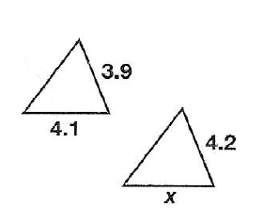
Practice Problems
Find the missing side(s) in each similar figure. Show Work!
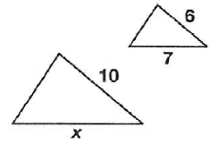
1. 2.

- _____________________ 2. _____________________

3. 4.
12

12 cm
w
4
x
3
y

{
16 cm
6
4 cm

x = ________ y = ________ w = ________

5. 6.

6 cm
3.8
j
k
6
4
10
4 cm
7 cm
{

b

5. j = ________ k = ________ b = ________

